The Rosie Hood Band

Advancing pack
Hospitality rider / Notes for Comperes / Technical Spec

Nicola Beazley  She/her  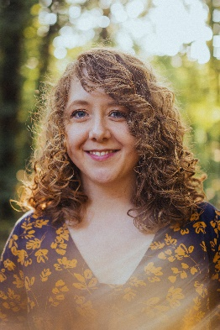 | Rosie Butler-Hall  She/her  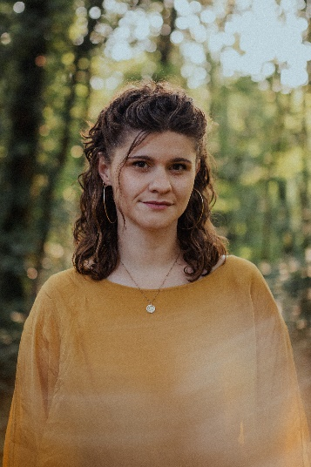 | Rosie Hood  She/her  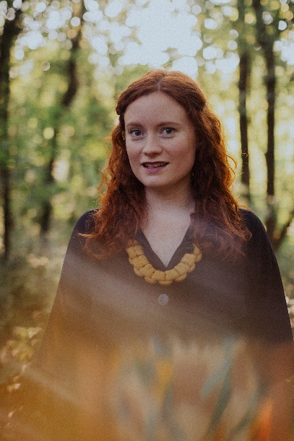 | Robyn Wallace  They/them  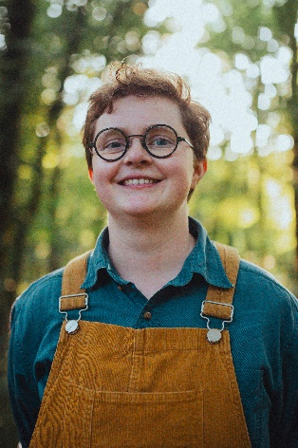

Hospitality rider

Accommodation
4 x single hotel/B&B rooms. Occasionally we will require a family room instead of one of the singles, please check to confirm before booking.

Green Room
Please provide a private place for the 4 band members to relax before their performance. The following would be greatly appreciated:
- Kettle and mugs
- Tea and Coffee (preferably filter/ground)
- Milk and Oat milk
- Honey, lemon & fresh ginger if possible
- Fruit, nuts, lentil crisps or other healthy snacks
- Access to drinking water, we’ll bring our own water bottles
- 2 x bottles of local ales
- 2 x bottles of lager
- A glass of white wine from the venue bar if possible (a whole bottle is not necessary!)

Meal (if provided)
Please either provide a hot meal or a buy-out of £10 per person.
If providing a meal, please note the following dietary requirements
- Nicola Beazley: dairy-free
- Rosie Hood: vegetarian
- Rosie Butler Hall: no special dietary requirements
- Robyn Wallace: no special dietary requirements

Thank you for having us and please just let me know if any of this isn’t possible. We’re also always interested in any local specialities!

Notes for comperes

Line-up

Rosie Hood – vocals/tenor guitar/baritone ukulele
Nicola Beazley – fiddle/vocals
Robyn Wallace – melodeon
Rosie Butler-Hall – fiddle/vocals

Pronouns

Rosie, Nicola and Rosie BH’s pronouns are she/her
e.g. “She was nominated for the Horizon award…”

Robyn’s pronouns are they/them
e.g. “They play the melodeon…”

Biography

A Horizon Folk Award nominee, Rosie Hood is known for her powerful, clear vocals and captivating performances combining poetic writing with honest interpretations of traditional English songs. In her ‘Classy’ (MOJO) 4-piece, Rosie is joined by fiddle-player Nicola Beazley, melodeon-player & percussionist Robyn Wallace and fiddle-player Rosie Butler-Hall. The instrumentalists bring dynamic lift and drive, expanding Rosie’s vision to re-work traditional songs and bring unheard stories to life. ‘To me, the story is always the most important thing, that’s the ‘Seed Of Gold’ within a song’ explains Rosie. The band released their debut album, Seed of Gold, in November 2023.

Here is some information you could include in your introduction about the Band:

- We released our debut album album, A Seed Of Gold, in November 2023 to favourable reviews:
‘A classy band’ - MOJO Magazine
‘An absolute joy’ – Folk London

- We perform re-workings of traditional English songs as well as original material, touching on politics, struggle, women’s voices and unheard stories

- We all live in Sheffield though originally both Rosies grew up in Wiltshire and Nic and Robyn are from Rochdale

- Rosie was nominated for the Horizon award at the BBC Radio 2 Folk Awards back in 2016

- We have CDs for sale (and can take card payments!)

Tech Spec 2024

Nicola Beazley | Rosie Butler-Hall | Rosie Hood | Robyn Wallace

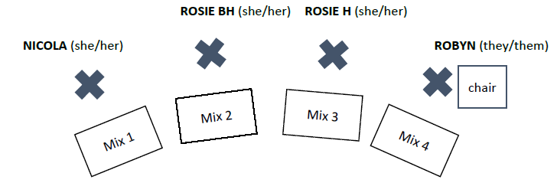
The band will be traveling with all their own Microphones, DI Boxes and Preamps.
Please provide the following equipment:
- A minimum of twelve (12) working XLR cables of suitable length for the size of the performance area.
- Four (4) tall boom microphone stands with telescopic booms.
- Two (2) short boom stands (kick drum/guitar amp style).
- Four (4) matching wedge monitor speakers.
- Two (2) 4-way power strips at the front of the stage for pedals etc.
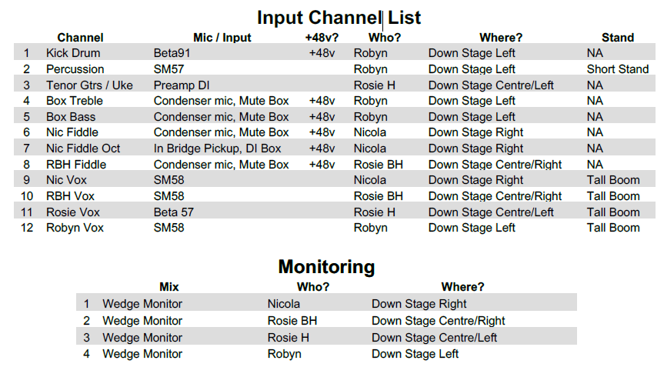

PLEASE GET IN CONTACT ASAP IF YOU WILL STRUGGLE TO MEET THIS SPEC
WE ARE ABLE TO BRING ADDITIONAL EQUIPMENT TO HELP MAKE THE SHOW WORK

Tech Contact: Tom A Wright / tom@poweredflightmusic.com / 07875 003905

